Healthcare Analytics using Snowflake and AWS

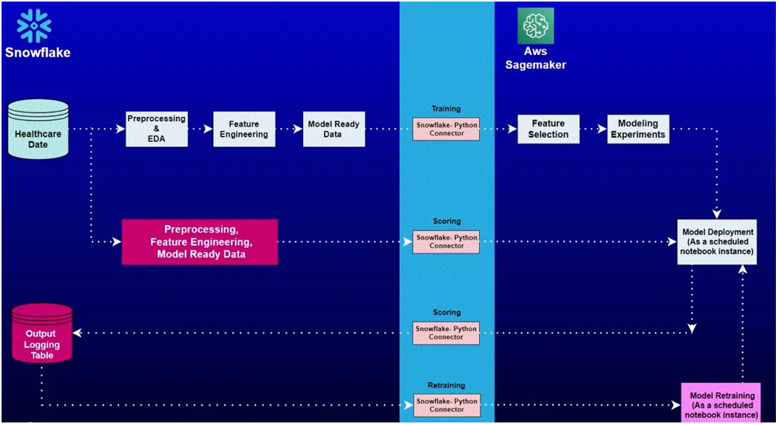
Project Overview
Healthcare analytics helps healthcare providers improve patient outcomes, optimize hospital operations, and reduce treatment costs through data-driven decision making. One of the most important healthcare metrics is Length of Stay (LOS), which represents the amount of time a patient spends in a healthcare facility.
This project develops an end-to-end healthcare analytics solution using Snowflake and AWS SageMaker to predict patient Length of Stay (LOS). The system performs data analysis, feature engineering, machine learning model development, deployment, scoring, and automated scheduling to provide healthcare organizations with actionable insights.
Aim
1. Perform Data Analysis using Snowflake
2. Build Machine Learning models to predict patient Length of Stay (LOS)
3. Schedule AWS SageMaker notebooks
4. Perform live scoring and prediction insertion into Snowflake
5. Send automated status notifications
Data Description
Training Data:
- Approximately 230,000 patient records
- Multiple hospitals and regions
- 19 features
Prediction Data:
- Approximately 71,000 patient records
- Simulation dataset for scoring and forecasting
Tech Stack
Tools:
- AWS SageMaker
- Snowflake
Language:
- Python
Libraries:
- snowflake-connector-python
- snowflake-sqlalchemy
- pandas
- numpy
- scikit-learn
- xgboost
Approach
1. Snowflake Setup
- Introduction to Snowflake UI
- Snowflake Worksheets
2. Exploratory Data Analysis (EDA)
- Data exploration within Snowflake
- SQL-based analysis
3. Feature Engineering
- Data transformation
- Feature creation in Snowflake
4. AWS SageMaker Setup
- Notebook configuration
- Environment preparation
5. Data Integration
- Fetch data from Snowflake
- Use SnowSQL connectors and SQLAlchemy
6. Data Preprocessing
- Missing value handling
- Data cleaning
- Feature preparation
7. Feature Selection
- Identify important variables
8. Model Development
- Linear Regression
- Random Forest Regression
- XGBoost Regression
9. Model Prediction
- Predict patient Length of Stay
10. Snowflake Integration
- Insert predictions back into Snowflake
11. Scheduling and Automation
- Schedule AWS SageMaker notebooks
- Automate scoring workflows
12. Notification System
- Send status emails
- Monitor execution status
Project Structure
Data/
├── health_data.csv
└── simulation_data.csv
Python_Files/
├── SageMaker notebooks
├── Model training scripts
└── Scoring scripts
SQL_Queries/
├── EDA Queries
├── Feature Engineering Queries
└── Scoring Queries
Project Takeaways
1. Snowflake Architecture and UI
2. Data Analysis using Snowflake Worksheets
3. Common Table Expressions (CTEs)
4. Feature Engineering in Snowflake
5. SnowSQL Connector Usage
6. AWS SageMaker Setup
7. Machine Selection in SageMaker
8. Data Preprocessing Techniques
9. Feature Selection Methods
10. XGBoost Regression Modeling
11. Notebook Scheduling
12. Email Notification Systems
13. Live Prediction Pipelines
14. Snowflake and AWS Integration
15. Healthcare Analytics
Business Benefits
- Improved patient outcome prediction
- Reduced hospital operational costs
- Better resource utilization
- Proactive patient care planning
- Automated healthcare reporting
- Scalable cloud-based analytics platform

